Statement on co-enrolment to VIVALDI and PRINCIPLE studies – September 2020

The VIVALDI and PRINCIPLE studies are both focussing on COVID-19 infection in older people in the UK. This is because these people are more likely to become severely ill or to die if they become infected. For this reason, the Chief Medical Officer for England, Professor Chris Whitty, and the National Institute of Health Research (NIHR) have prioritised these studies out of all of the national studies and labelled them of Urgent Public Health Importance (UPHI). The VIVALDI study is collecting information on people working and living in care homes, regardless of whether they are or have been infected, whereas the PRINCIPLE study is focussing on treatments for those who are currently ill with Covid-19.

Care homes are able to participate in both of these studies as there is no overlap in what study participants will be asked to do. The study teams encourage care homes to participate in as many priority COVID-19 research studies as possible, including any future vaccine studies, as this will increase the amount and quality of information that can be collected in order to limit the number of older people who become infected and severely unwell with COVID-19. Taking part in these critically important studies is also a mark of quality care.
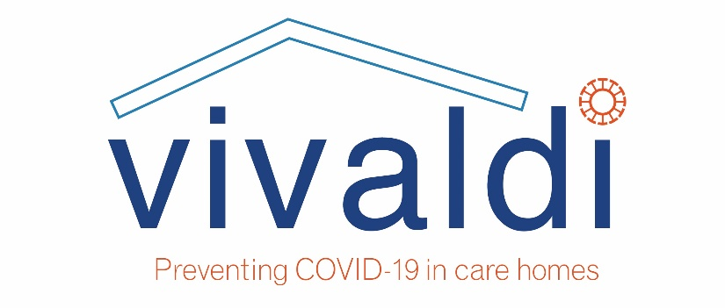
The VIVALDI study is an observational study which is testing staff and residents in care homes in England for current or past COVID-19 infection and following them up to see how these numbers change over time. The tests will be carried out using swabs from the national testing programme and blood tests that will be arranged by the study team. This is in order to gain an understanding of how many people are and have been infected with COVID-19 since the start of the 2020 pandemic. To be involved, all that your care home needs to do is to let the study team know who will then arrange the visits for blood tests. You will not need to perform any extra swabs to those that are already being carried out in your care home through the government programme. By taking part, your care home will be helping government officials and local teams to decide on policies and actions that can prevent more COVID-19 infections in care homes in future waves of the pandemic.

For further information please visit https://www.ucl.ac.uk/health-informatics/research/vivaldi-study or contact:
Vivaldi.covid19@ucl.ac.uk

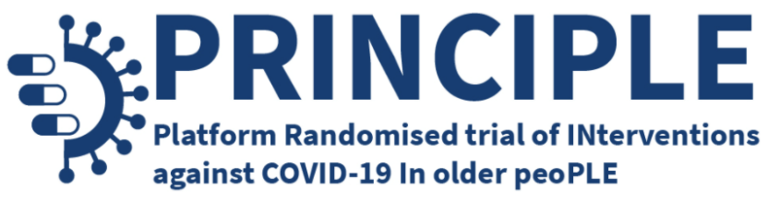

PRINCIPLE is a UK wide clinical trial to find COVID-19 treatments in the community. The trial is recruiting people with confirmed or suspected COVID-19 who are aged 50 and over and have a comorbidity, or who are aged 65 and over, with or without comorbidity. To be involved in the study as a care home you simply need to help us identify residents with symptoms of COVID-19. All recruitment and follow-up procedures are conducted online or by our trial team over the phone with the resident or a study partner, swabs and medication are sent to the resident. The patient’s GP or the trial’s clinical team will confirm that it is safe and appropriate for the resident to take part. Ensuring affected people are given the opportunity to contribute to PRINCIPLE is a great service that we can offer care home residents. By taking part, your care home will be helping find safe and effective treatments for COVID-19.

For further information please visit: www.principletrial.org or contact: principle@phc.ox.ac.uk

